Chapter 5

Advanced Data Modeling

Discussion Focus

Your discussion can be divided into three parts to reflect the chapter coverage:

- The first part of the discussion covers the Extended Entity Relationship Model.
  - Start by exploring the use of entity supertypes and subtypes.
  - Use the specialization hierarchy example in Figure 5.2 to illustrate the main constructs.
  - Illustrate the benefits of attribute inheritance and relationship inheritance.
  - Remember that an entity supertype and an entity subtype are related in a 1:1 relationship.
  - Emphasize the use of the subtype discriminator and then explain the concept of overlapping and disjoint constraints in relation to entity subtypes.
  - The completeness constraint indicates whether all entity supertypes must have at least one subtype.
  - Explore the specialization and generalization hierarchies.
  - Finally, explain the use of entity clusters as an alternative method to simplify crowded data models.
- The second part of the discussion covers the importance of proper primary key selection.
  - Start by clearly stating the function of a PK -- identification -- and how that function differs from the descriptive nature of the other attributes in an entity. Explain the use of PKs to uniquely identify each entity instance.
  - Discuss natural keys, primary keys, and surrogate keys.
  - Examine the primary key guidelines that specify the PK characteristics. PKs must be unique, non-intelligent, they do not change over time, they are ideally composed of a single attribute, they are numeric, and they are security compliant.
  - Finally, contrast the use of surrogate and composite primary keys. Remind students that composite primary keys are useful in composite entities where each primary key combination is allowed only once in the M:N relationship.
- The third part of the discussion covers four special design cases:
  - Implementing 1:1 relationships.
  - Maintaining the history of time-variant data.
  - Fan traps.
  - Redundant relationships.

Answers to Review Questions

- What is an entity supertype, and why is it used?

An entity supertype is a generic entity type that is related to one or more entity subtypes, where the entity supertype contains the common characteristics and the entity subtypes contain the unique characteristics of each entity subtype. The reason for using supertypes is to minimize the number of nulls and to minimize the likelihood of redundant relationships.

- What kinds of data would you store in an entity subtype?
An entity subtype is a more specific entity type that is related to an entity supertype, where the entity supertype contains the common characteristics and the entity subtypes contain the unique characteristics of each entity subtype. The entity subtype will store the data that is specific to the entity; that is, attributes that are unique the subtype.

- What is a specialization hierarchy?

A specialization hierarchy depicts the arrangement of higher-level entity supertypes (parent entities) and lower-level entity subtypes (child entities). To answer the question precisely, we have used the text’s Figure 5.2. (We have reproduced the figure on the next page for your convenience.) Figure 5.2 shows the specialization hierarchy formed by an EMPLOYEE supertype and three entity subtypes—PILOT, MECHANIC, and ACCOUNTANT.

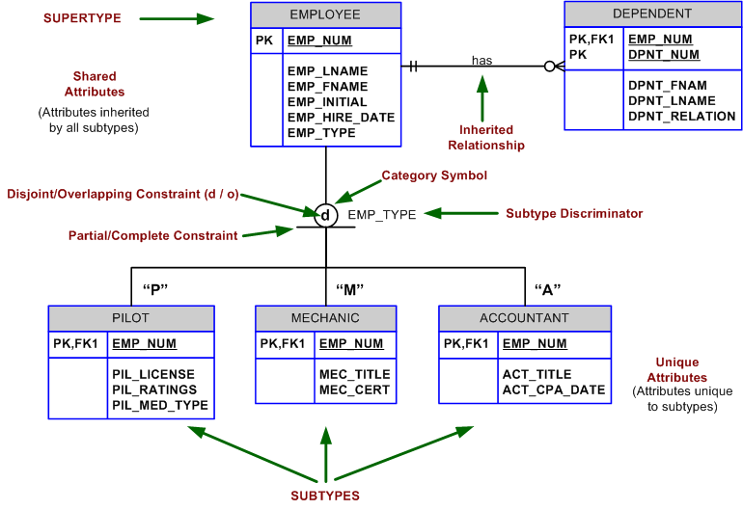
(Text) FIGURE 5.2 A Specialization Hierarchy

The specialization hierarchy shown in Figure 5.2 reflects the 1:1 relationship between EMPLOYEE and its subtypes. For example, a PILOT subtype occurrence is related to one instance of the EMPLOYEE supertype and a MECHANIC subtype occurrence is related to one instance of the EMPLOYEE supertype.

- What is a subtype discriminator? Given an example of its use.

A subtype discriminator is the attribute in the supertype entity that is used to determine to which entity subtype the supertype occurrence is related. For any given supertype occurrence, the value of the subtype discriminator will determine which subtype the supertype occurrence is related to. For example, an EMPLOYEE supertype may include the EMP_TYPE value “P” to indicate the PROFESSOR subtype.

- What is an overlapping subtype? Give an example.

Overlapping subtypes are subtypes that contain non-unique subsets of the supertype entity set; that is, each entity instance of the supertype may appear in more than one subtype. For example, in a university environment, a person may be an employee or a student or both. In turn, an employee may be a professor as well as an administrator. Because an employee also may be a student, STUDENT and EMPLOYEE are overlapping subtypes of the supertype PERSON, just as PROFESSOR and ADMINISTRATOR are overlapping subtypes of the supertype EMPLOYEE. The text’s Figure 5.4 (reproduced next for your convenience) illustrates overlapping subtypes with the use of the letter O inside the category shape.

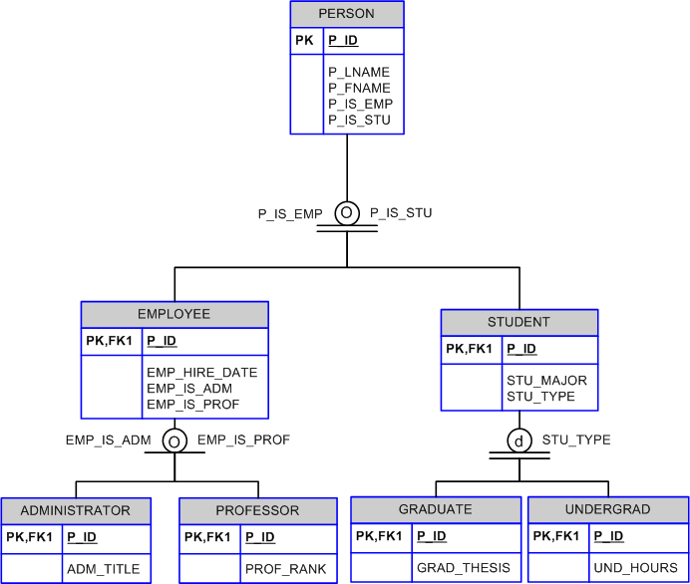

(Text) FIGURE 5.4 Specialization Hierarchy with Overlapping Subtypes

- What is a disjoint subtype? Give an example.

Disjoint subtypes, also known as nonoverlapping subtypes, are subtypes that contain a unique subset of the supertype entity set; in other words, each entity instance of the supertype can appear in only one of the subtypes. For example, in Figure 5.2, shown in Question 3, an employee (supertype) who is a pilot (subtype) can appear only in the PILOT subtype, not in any of the other subtypes. In an ERD, such disjoint subtypes are indicated by the letter d inside the category shape. See Figure 5.2 in textbook or in Question 3. Also, see Figure 5.5 Disjoint and Overlapping Subtypes in the textbook.

- What is the difference between partial completeness and total completeness?

Partial completeness means that not every supertype occurrence is a member of a subtype; that is, there may be some supertype occurrences that are not members of any subtype. Total completeness means that every supertype occurrence must be a member of at least one subtype.

For questions 8 – 10, refer to Figure Q5.8
FIGURE Q5.8 The PRODUCT data model

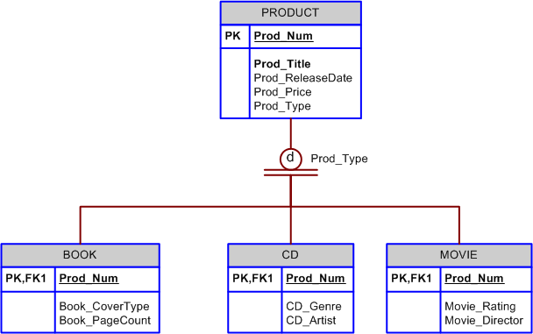

- List all of the attributes of a movie.

Recall that the subtype inherits all of the attributes and relationships of the supertype. Therefore, all of the attributes of a subtype include the common attributes from the supertype plus the unique (unique to that subtype) attributes from the subtype. All of the attributes of a movie would be:
- Prod_Num
- Prod_Title
- Prod_ReleaseDate
- Prod_Price
- Prod_Type
- Movie_Rating
- Movie_Director

- According to the data model, is it required that every entity instance in the PRODUCT table be associated with an entity instance in the CD table? Why or why not?

No. The completeness constraint for the data model shows a total completeness constraint from PRODUCT to the subtypes. However, the total completeness constraint indicates that every instance in the supertype (PRODUCT) must be associated with one row in some subtype, not all subtypes. Since the subtypes are designated as disjoint, or exclusive, then every row in the supertype is associated a row in only one subtype. For some products that subtype will be CD, but for other products the subtype will be either Movie or Book.

- Is it possible for a book to appear in the BOOK table without appearing in the PRODUCT table? Why or why not?

No. Subtypes can only exist within the context of a supertype.

- What is an entity cluster, and what advantages are derived from its use?

An entity cluster is a “virtual” entity type used to represent multiple entities and relationships in the ERD. An entity cluster is formed by combining multiple interrelated entities into a single abstract entity object. An entity cluster is considered “virtual” or “abstract” in the sense that it is not actually an entity in the final ERD, but rather a temporary entity used to represent multiple entities and relationships with the purpose of simplifying the ERD and thus enhancing its readability.

- What primary key characteristics are considered desirable? Explain why each characteristic is considered desirable.

Desirable PK characteristics are summarized in the text’s Table 5.3, reproduced below for your convenience. The table also includes the reason why each characteristic is desirable. (See the Rationale column.)

PK Characteristic | Rationale
Unique values | The PK must uniquely identify each entity instance. A primary key must be able to guarantee unique values. It cannot contain nulls.
Nonintelligent | The PK should not have embedded semantic meaning. An attribute with embedded semantic meaning is probably better used as a descriptive characteristic of the entity rather than as an identifier. In other words, a student ID of “650973” would be preferred over “Smith, Martha L.” as a primary key identifier.
No change over time | If an attribute has semantic meaning, it may be subject to updates. This is why names do not make good primary keys. If you have “Vickie Smith” as the primary key, what happens when she gets married? If a primary key is subject to change, the foreign key values must be updated, thus adding to the database work load. Furthermore, changing a primary key value means that you are basically changing the identity of an entity.
Preferably single-attribute | A primary key should have the minimum number of attributes possible. Single-attribute primary keys are desirable but not required. Single-attribute primary keys simplify the implementation of foreign keys. Having multiple-attribute primary keys can cause primary keys of related entities to grow through the possible addition of many attributes, thus adding to the database work load and making (application) coding more cumbersome.
Preferably numeric | Unique values can be better managed when they are numeric because the database can use internal routines to implement a “counter-style” attribute that automatically increments values with the addition of each new row. In fact, most database systems include the ability to use special constructs, such as Autonumber in MS Access, to support self-incrementing primary key attributes.
Security complaint | The selected primary key must not be composed of any attribute(s) that might be considered a security risk or violation. For example, using a Social Security number as a PK in an EMPLOYEE table is not a good idea.

TABLE 5.3 Desirable Primary Key Characteristics

- Under what circumstances are composite primary keys appropriate?

Composite primary keys are particularly useful in two cases:
- As identifiers of composite entities, where each primary key combination is allowed only once in the M:N relationship.
- As identifiers of weak entities, where the weak entity has a strong identifying relationship with the parent entity.

To illustrate the first case, assume that you have a STUDENT entity set and a CLASS entity set. In addition, assume that those two sets are related in a M:N relationship via an ENROLL entity set in which each student/class combination may appear only once in the composite entity. The text’s Figure 5.7 (reproduced here for your convenience) shows the ERD to represent such a relationship.

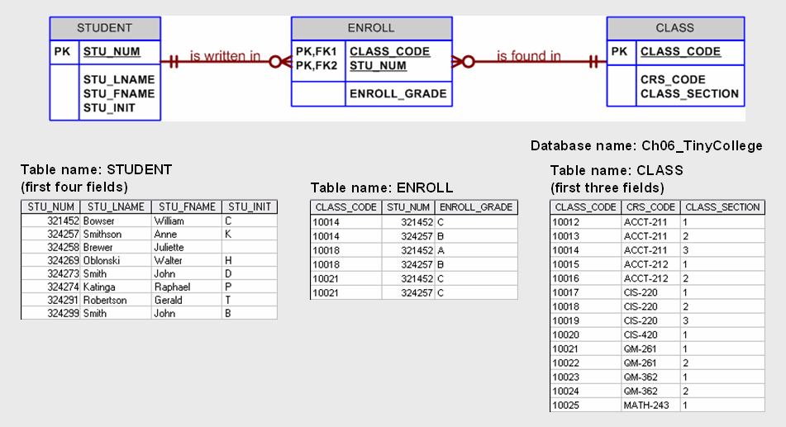

(Text) FIGURE 5.7 M:N Relationship Between Student and Class
As shown in the text’s Figure 5.7, the composite primary key automatically provides the benefit of ensuring that there cannot be duplicate values—that is, it ensures that the same student cannot enroll more than once in the same class.
In the second case, a weak entity in a strong identifying relationship with a parent entity is normally used to represent one of two cases:
- A real-world object that is existent dependent on another real-world object. Those types of objects are distinguishable in the real world. A dependent and an employee are two separate people who exist independent of each other. However, such objects can exist in the model only when they relate to each other in a strong identifying relationship. For example, the relationship between EMPLOYEE and DEPENDENT is one of existence dependency in which the primary key of the dependent entity is a composite key that contains the key of the parent entity.
- A real-world object that is represented in the data model as two separate entities in a strong identifying relationship. For example, the real-world invoice object is represented by two entities in a data model: INVOICE and LINE. Clearly, the LINE entity does not exist in the real world as an independent object, but rather as part of an INVOICE.

In both cases, having a strong identifying relationship ensures that the dependent entity can exist only when it is related to the parent entity. In summary, the selection of a composite primary key for composite and weak entity types provides benefits that enhance the integrity and consistency of the model.

- What is a surrogate primary key, and when would you use one?

A surrogate primary key is an “artificial” PK that is used to uniquely identify each entity occurrence when there is no good natural key available or when the “natural” PK would include multiple attributes. A surrogate PK is also used if the natural PK would be a long text variable. The reason for using a surrogate PK is to ensure entity integrity, to simplify application development – by making queries simpler – to ensure query efficiency – for example, a query based on a simple numeric attribute is much faster than one based on a 200-bit character string -- and to ensure that relationships between entities can be created more easily than would be the case with a composite PK that may have to be used as a FK in a related entity.

- When implementing a 1:1 relationship, where should you place the foreign key if one side is mandatory and one side is optional? Should the foreign key be mandatory or optional?

Section 5.4.1 provides a detailed discussion. The text’s Table 5.5, reproduced here for your convenience, shows the rationale for selecting the foreign key in a 1:1 relationship based on the relationship properties in the ERD.

Case | ER Relationship Constraints | Action
I | One side is mandatory and the other side is optional. | Place the PK of the entity on the mandatory side in the entity on the optional side as a FK and make the FK mandatory.
II | Both sides are optional. | Select the FK that causes the fewest number of nulls or place the FK in the entity in which the (relationship) role is played.
III | Both sides are mandatory. | See Case II or consider revising your model to ensure that the two entities do not belong together in a single entity.

TABLE 5.5 Selection of Foreign Key in a 1:1 Relationship

- What are time-variant data, and how would you deal with such data from a database design point of view?

As the label implies, time variant data are time-sensitive. For example, if a university wants to keep track of the history of all administrative appointments by date of appointment and date of termination, you see time-variant data at work.

- What is the most common design trap, and how does it occur?

A design trap occurs when a relationship is improperly or incompletely identified and therefore, it is represented in a way that is not consistent with the real world. The most common design trap is known as a fan trap. A fan trap occurs when you have one entity in two 1:M relationships to other entities, thus producing an association among the other entities that is not expressed in the model.

Problem Solutions

- Given the following business scenario, create a Crow’s Foot ERD using a specialization hierarchy if appropriate.

Two-Bit Drilling Company keeps information on employees and their insurance dependents. Each employee has an employee number, name, date of hire, and title. If an employee is an inspector, then the date of certification and the renewal date for that certification should also be recorded in the system. For all employees, the Social Security number and dependent names should be kept. All dependents must be associated with one and only one employee. Some employees will not have dependents, while others will have many dependents.

The data model for this solution is shown in FigP5.1 below.

FIGURE P5.1 Two-Bit Drilling Company ERD
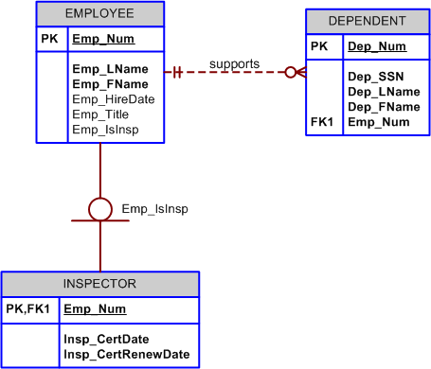

In this scenario, a specialization hierarchy is appropriate because there is an identifiable type or kind of employee (Inspectors), and additional attributes are recorded that are specific to just that kind or type. It is worth noting that if there is only a single subtype, the disjoint/overlapping designation may be omitted – if there is only one subtype then there is no other subtype to overlap or be disjoint from. Also, when there is only a single subtype, the completeness constraint is always partial completeness. If the completeness constraint were identified as total completeness, that would mean that every employee must be an inspector, in which inspector would be a synonym for employee not a kind of employee.

- Given the following business scenario, create a Crow’s Foot ERD using a specialization hierarchy if appropriate.

Tiny Hospital keeps information on patients and hospital rooms. The system assigns each patient a patient ID number. In addition, the patient’s name and date of birth are recorded. Some patients are resident patients (they spend at least one night in the hospital) and others are outpatients (they are treated and released). Resident patients are assigned to a room. Each room is identified by a room number. The system also stores the room type (private or semiprivate), and room fee. Over time, each room will have many patients that stay in it. Each resident patient will stay in only one room. Every room must have had a patient, and every resident patient must have a room.

The data model for this scenario is given in Figure P5.2 below.

FIGURE P5.2 Tiny Hospital ERD

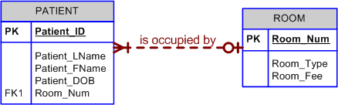

Note that in this scenario, a specialization hierarchy is not appropriate. While resident patients are an identifiable kind or type of patient instance, there are not additional attributes that are unique to only that kind or type of patient. Participation in a relationship that is unique to a particular kind or type of instance is not sufficient justification for a specialization hierarchy. Indicating that only some instances will participate in a relationship is addressed by the optional participation designation. In this scenario, all resident patients must have a room; however, not all patients are resident patients so ROOM is optional to patient. If students ask about the need for an attribute to distinguish between outpatients and resident patients, remind them that in this limited scenario the only distinction between outpatients and resident patients is whether or not they are associated with a room. Therefore, they can consider the Room_Num foreign key in the PATIENT table can serve in that capacity.

- Given the following business scenario, create a Crow’s Foot ERD using a specialization hierarchy if appropriate.

Granite Sales Company keeps information on employees and the departments that they work in. For each department, the department name, internal mail box number, and office phone extension are kept. A department can have many assigned employees, and each employee is assigned to only one department. Employees can be salaried employees, hourly employees, or contract employees. All employees are assigned an employee number. This is kept along with the employee’s name and address. For hourly employees, hourly wage and target weekly work hours are stored (e.g. the company may target 40 hours/week for some, 32 hours/week for others, and 20 hours/week for others). Some salaried employees are salespeople that can earn a commission in addition to their base salary. For all salaried employees, the yearly salary amount is recorded in the system. For salespeople, their commission percentage on sales and commission percentage on profit are stored in the system. For example, John is a salesperson with a base salary of $50,000 per year plus 2-percent commission on the sales price for all sales he makes plus another 5 percent of the profit on each of those sales. For contract employees, the beginning date and end dates of their contract are stored along with the billing rate for their hours.

The data model for this scenario is given in Figure P5.3 below.

FIGURE P5.3 Granite Sales ERD.
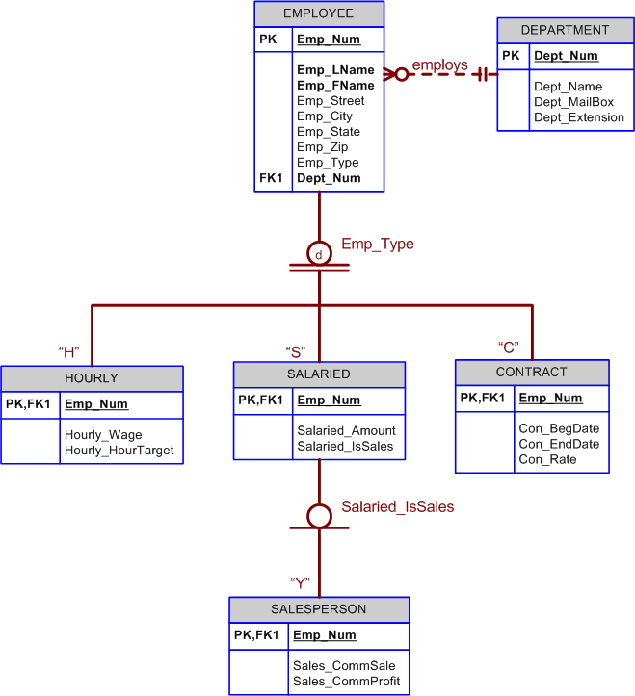

4. In Chapter 4, you saw the creation of the Tiny College database design. That design reflected such business rules as “a professor may advise many students” and “a professor may chair one department.” Modify the design shown in Figure 4.35 to include these business rules:
- An employee could be staff or a professor or an administrator.
- A professor may also be an administrator.
- Staff employees have a work level classification, such a Level I and Level II.
- Only professors can chair a department. A department is chaired by only one professor.
- Only professors can serve as the dean of a college. Each of the university’s colleges is served by one dean.
- A professor can teach many classes.
- Administrators have a position title.

Given that information, create the complete ERD containing all primary keys, foreign keys, and main attributes.

The solution is shown in Figure P5.4 below.

FIGURE P5.4 Updated Tiny College ERD

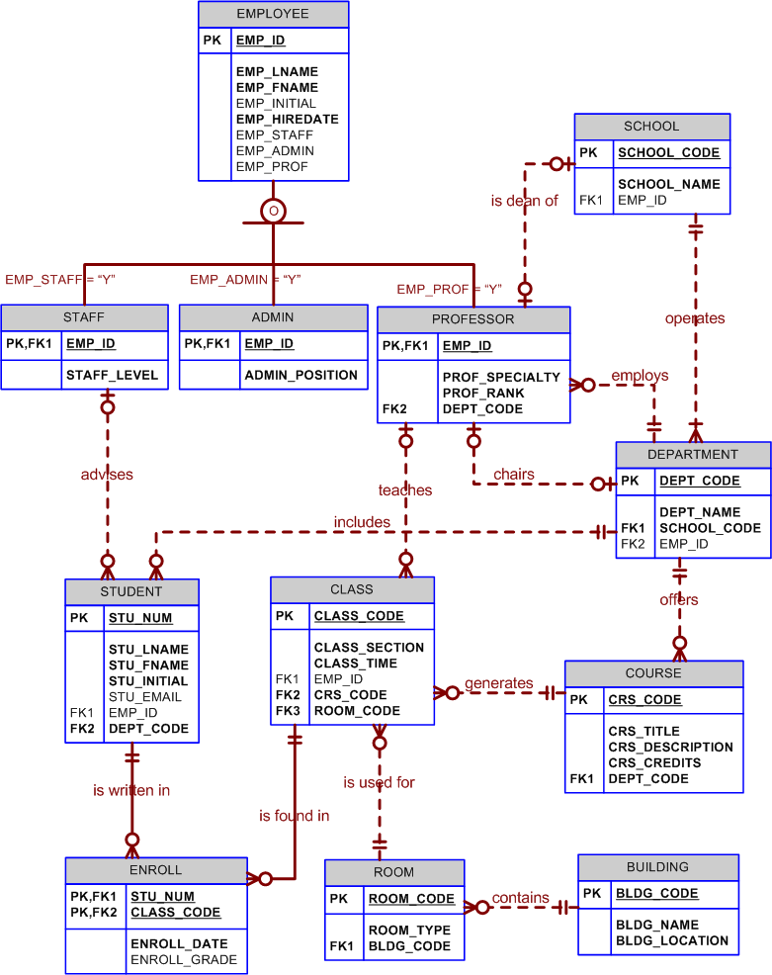
Note that the business rules require that the subtypes be overlapping for some subtypes but disjoint for others. Specifically, the STAFF subtype is disjoint from ADMIN and PROFESSOR, but ADMIN and PROFESSOR are overlapping. Such complex requirements may be implemented in the database through the use of database constraints as described in Chapter 7, Introduction to Structured Query Language (SQL).

- Tiny College wants to keep track of the history of all administrative appointments (date of appointment and date of termination). (Hint: Time variant data are at work.) The Tiny College chancellor may want to know how many deans worked in the College of Business between January 1, 1960 and January 1, 2018 or who the dean of the College of Education was in 1990. Given that information, create the complete ERD containing all primary keys, foreign keys, and main attributes.

The solution is shown in the following figure:

FIGURE P5.5 Tiny College Job History ERD Segment

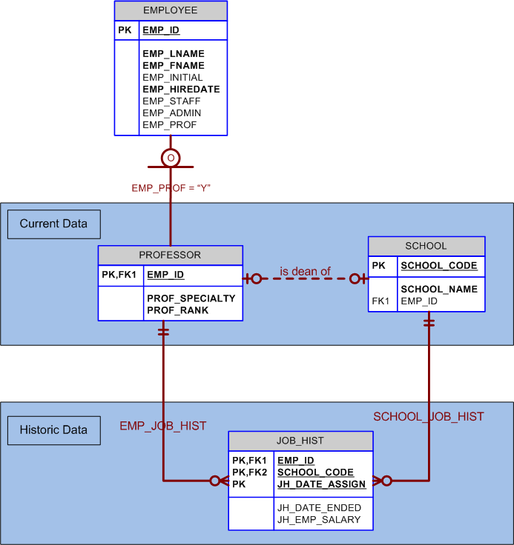

6. Some Tiny College staff employees are information technology (IT) personnel. Some IT personnel provide technology support for academic programs. Some IT personnel provide technology infrastructure support. Some IT personnel provide technology support for academic programs and technology infrastructure support. IT personnel are not professors. IT personnel are required to take periodic training to retain their technical expertise. Tiny College tracks all IT personnel training by date, type, and results (completed vs. not completed). Given that information, create the complete ERD containing all primary keys, foreign keys, and main attributes.

This problem provides an opportunity to reinforce the idea that to qualify as a subtype, the identifiable kind or type of instance must include additional attributes – being an identifiable kind or type of entity instance is necessary but not sufficient to justify the create of subtypes. Given the minimal attributes specified in the problem, the solution would be as shown in Figure 5.6a.

FIGURE 5.6a Minimal Tiny College IT Staffing Solution

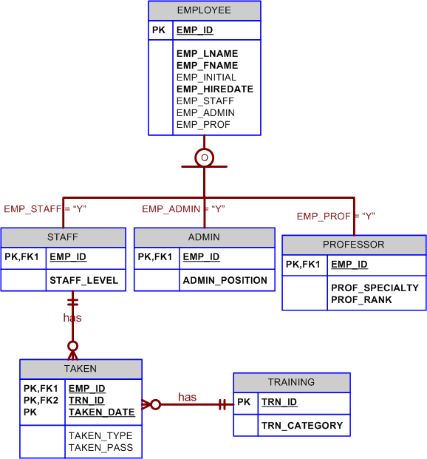

If, as is often the case in the problems included in textbook, we assume that the attributes specified are just a subset of the complete attribute requirements for each entity, we can consider what the data model would be given that additional attributes that are unique to the described kinds of entity instances will exist. In that case, the expanded solution including subtypes for the described kinds of staff members is shown in Figure 5.6b.

FIGURE 5.6b Expanded Tiny College IT Staffing Solution

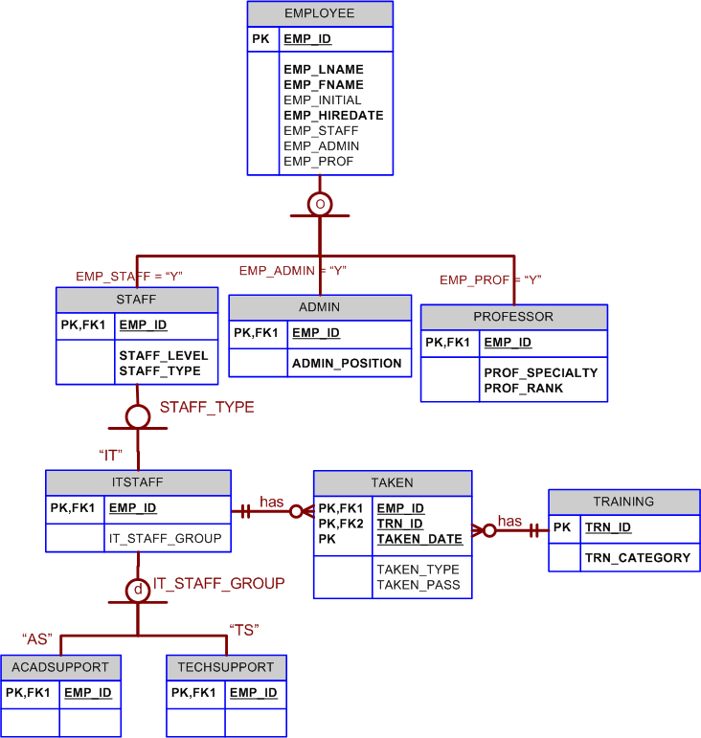

Note that in the specification of ITSTAFF as a subtype of STAFF, there is no disjoint/overlapping designation for the subtype. When there is only one subtype, there is nothing to be disjointed from or to overlap with; therefore, the designation may be safely omitted.

7. The FlyRight Aircraft Maintenance (FRAM) division of the FlyRight Company (FRC) performs all maintenance for FRC’s aircraft. Produce a data model segment that reflects the following business rules:
- All mechanics are FRC employees. Not all employees are mechanics.
- Some mechanics are specialized in engine (EN) maintenance. Some mechanics are specialized in airframe (AF) maintenance. Some mechanics are specialized in avionics (AV) maintenance. (Avionics are the electronic components of an aircraft that are used in communication and navigation.) All mechanics take periodic refresher courses to stay current in their areas of expertise. FRC tracks all course taken by each mechanic—date, course type, certification (Y/N), and performance.
- FRC keeps a history of the employment of all mechanics. The history includes the date hired, date promoted, date terminated, and so on. (Note: The “and so on” component is, of course, not a real-world requirement. Instead, it has been used here to limit the number of attributes you will show in your design.)

Given those requirements, create the Crow’s Foot ERD segment.

The solution is shown in the following figure:
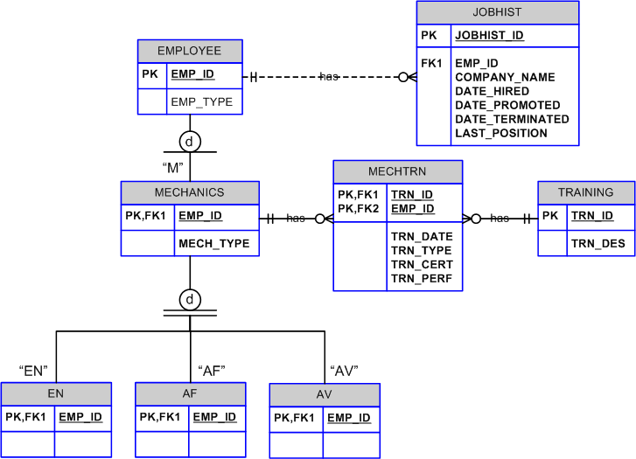
Note that this is a very simplified version of the aircraft problem domain. The purpose is to help students with the modeling notation for specialization hierarchies and to illustrate how this notation is different from the original entity relationship models. To truly justify the existence of the mechanic subtypes, each subtype MUST have attributes that are unique to that particular subtype. A good class exercise is to have students suggest attributes that may be unique to each subtype.

8. “Martial Arts R Us” (MARU) needs a database. MARU is a martial arts school with hundreds of students. It is necessary to keep track of all the different classes that are being offered, who is assigned to teach each class, and which students attend each class. Also, it is important to track the progress of each student as they advance. Create a complete Crow’s Foot ERD for these requirements:
- Students are given a student number when they join the school. This is stored along with their name, date of birth, and the date they joined the school.
- All instructors are also students, but clearly, not all students are instructors. In addition to the normal student information, for each instructor, the date that they start working as an instructor must be recorded, along with their instructor status (compensated or volunteer).
- An instructor may be assigned to teach any number of classes, but each class has one and only one assigned instructor. Some instructors, especially volunteer instructors, may not be assigned to any class.
- A class is offered for a specific level at a specific time, day of the week, and location. For example, one class taught on Mondays at 5:00 pm in Room #1 is an intermediate-level class. Another class taught on Mondays at 6:00 pm in Room #1 is a beginner-level class. A third class taught on Tuesdays at 5:00 pm in Room #2 is an advanced-level class.
- Students may attend any class of the appropriate level during each week so there is no expectation that any particular student will attend any particular class session. Therefore, the actual attendance of students at each individual class meeting must be tracked.
- A student will attend many different class meetings; and each class meeting is normally attended by many students. Some class meetings may have no students show up for that meeting. New students may not have attended any class meetings yet.
- At any given meeting of a class, instructors other than the assigned instructor may show up to help. Therefore, a given class meeting may have several instructors (a head instructor and many assistant instructors), but it will always have at least the one instructor that is assigned to that class. For each class meeting, the date that the class was taught and the instructors’ roles (head instructor or assistant instructor) need to be recorded. For example, Mr. Jones is assigned to teach the Monday, 5:00 pm, intermediate class in Room #1. During one particular meeting of that class, Mr. Jones was present as the head instructor and Ms. Chen came to help as an assistant instructor.
- Each student holds a rank in the martial arts. The rank name, belt color, and rank requirements are stored. Each rank will have numerous rank requirements. Each requirement is considered a requirement just for the rank at which the requirement is introduced. Every requirement is associated with a particular rank. All ranks except white belt have at least one requirement.
- A given rank may be held by many students. While it is customary to think of a student as having a single rank, it is necessary to track each student’s progress through the ranks. Therefore, every rank that a student attains is kept in the system. New students joining the school are automatically given a white belt rank. The date that a student is awarded each rank should be kept in the system. All ranks have at least one student that has achieved that rank at some time.

The solution for this case is shown in Figure P5.8 below.

FIGURE P5.8 MARU ERD Solution

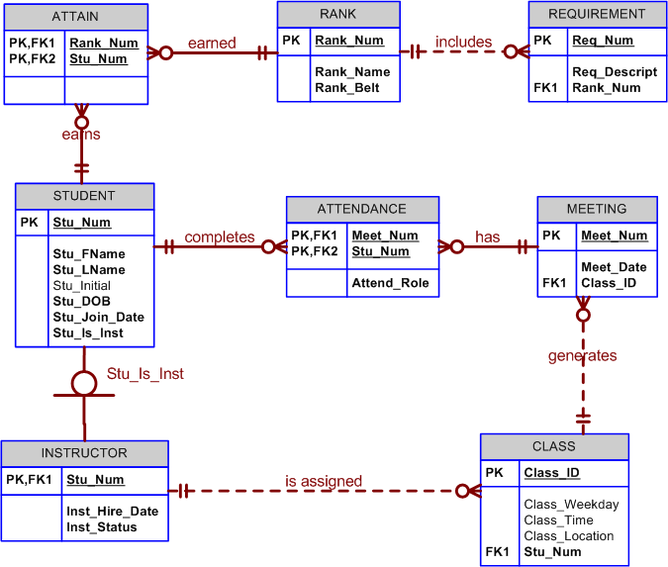

Notice that the figure includes surrogate keys for RANK, REQUIREMENT, and MEETING because the natural keys did not meet the requirements for a good primary key.

The most common areas for confusion among students on this particular case surround attendance in the class meetings. Students tend to think of relationship between CLASS and STUDENT similar to the M:N enroll relationship that they have seen throughout the textbook. In this case, however, the relationship is not an enrollment relationship – instead it is an attendance relationship. As described in the case, students do not enroll in any particular class. What must be tracked is the attendance for each individual class meeting. Therefore, the M:N relationship in this scenario is actually between the STUDENT and the individual class MEETING.

The case also provides an opportunity to reinforce the fact that subtypes inherit not only the attributes of the supertype but also the relationships. One requirement of the case is that the system must be able to track which instructors actually taught each class meeting. There is already a M:N relationship between STUDENT and MEETING that can be implemented with the ATTENDANCE bridge entity using only the Stu_Num and Meet_Num attributes. Students should consider that because INSTRUCTOR is a subtype of STUDENT, instructors are already associated in a M:N relationship with MEETING through that same bridge. By adding the Attend_Role attribute to ATTENDANCE, the bridge entity can properly track all students in a given class meeting and record what role they played in that meeting (e.g. student, assistant instructor, or head instructor).

Finally, it is worth pointing out to the students that requirements are described as being an attribute of a rank. Some students will immediate consider requirements to be an entity, while others will model requirement as an attribute of the RANK entity. Considering rank requirements to be an attribute of RANK is perfectly acceptable – however, it must be noted that as such rank requirements would be a multi-valued attribute. Therefore, the preferred implementation of a multi-valued attribute (creating a new entity for the multi-valued attribute) would result in the creation of the REQUIREMENT table anyway. So either way the student approaches the problem, it will eventually lead to the solution shown above.

9. The Journal of E-commerce Research Knowledge is a prestigious information systems research journal. It uses a peer-review process to select manuscripts for publication. Only about 10 percent of the manuscripts submitted to the journal are accepted for publication. A new issue of the journal is published each quarter. Create a complete ERD to support the business needs described below.
- Unsolicited manuscripts are submitted by authors. When a manuscript is received, the editor will assign the manuscript a number, and record some basic information about it in the system. The title of the manuscript, the date it was received, and a manuscript status of “received” are entered. Information about the author(s) is also recorded. For each author, the author’s name, mailing address, e-mail address, and affiliation (school or company for which the author works) is recorded. Every manuscript must have an author. Only authors that have submitted manuscripts are kept in the system. It is typical for a manuscript to have several authors. A single author may have submitted many different manuscripts to the journal. Additionally, when a manuscript has multiple authors, it is important to record the order in which the authors are listed in the manuscript credits.
- At her earliest convenience, the editor will briefly review the topic of the manuscript to ensure that the manuscript’s contents fall within the scope of the journal. If the content is not within the scope of the journal, the manuscript’s status is changed to “rejected” and the author is notified via e-mail. If the content is within the scope of the journal, then the editor selects three or more reviewers to review the manuscript. Reviewers work for other companies or universities and read manuscripts to ensure the scientific validity of the manuscripts. For each reviewer, the system records a reviewer number, reviewer name, reviewer e-mail address, affiliation, and areas of interest. Areas of interest are pre-defined areas of expertise that the reviewer has specified. An area of interest is identified by a IS code and includes a description (e.g. IS2003 is the code for “database modeling”). A reviewer can have many areas of interest, and an area of interest can be associated with many reviewers. All reviewers must specify at least one area of interest. It is unusual, but it is possible to have an area of interest for which the journal has no reviewers. The editor will change the status of the manuscript to “under review” and record which reviewers the manuscript was sent to and the date on which it was sent to each reviewer. A reviewer will typically receive several manuscripts to review each year, although new reviewers may not have received any manuscripts yet.
- The reviewers will read the manuscript at their earliest convenience and provide feedback to the editor regarding the manuscript. The feedback from each reviewer includes rating the manuscript on a 10-point scale for appropriateness, clarity, methodology, and contribution to the field, as well as a recommendation for publication (accept or reject). The editor will record all of this information in the system for each review received from each reviewer and the date that the feedback was received. Once all of the reviewers have provided their evaluations, the editor will decide whether or not to publish the manuscript and changed its status to “accepted” or “rejected”. If the manuscript will be published, the date of acceptance is recorded.
- Once a manuscript has been accepted for publication, it must be scheduled. For each issue of the journal, the publication period (Fall, Winter, Spring, or Summer), publication year, volume, and number are recorded. An issue will contain many manuscripts, although the issue may be created in the system before it is known which manuscripts will be published in that issue. An accepted manuscript appears in only one issue of the journal. Each manuscript goes through a typesetting process that formats the content, including fonts, font size, line spacing, justification, and so on. Once the manuscript has been typeset, its number of pages is recorded in the system. The editor will then decide which issue each accepted manuscript will appear in and the order of manuscripts within each issue. The order and the beginning page number for each manuscript must be stored in the system. Once the manuscript has been scheduled for an issue, the status of the manuscript is changed to “scheduled.” Once an issue is published, the print date for the issue is recorded, and the status of each manuscript in that issue is changed to “published.”

The solution for this case is shown in Figure P5.9 below.

FIGURE P5.9 Journal of E-commerce Research Knowledge ERD Solution
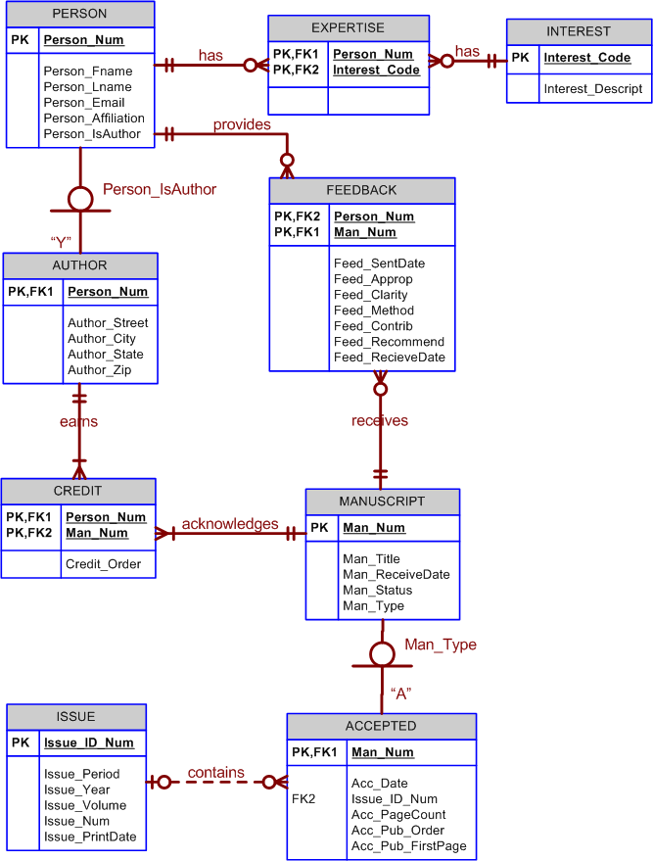

Again, this is another opportunity to stress to students that the creation of subtypes requires that there exist identifiable kinds or types of entity instances and that kind or type must have additional attributes that are unique to that kind or type. In this case, AUTHOR is a subtype because it is an identifiable kind or type of PERSON and it includes additional attributes that are unique to authors (i.e. the address attributes). There is no subtype for reviewers because there are no attributes that are unique to just that kind or type of PERSON. Reviewers do have relationships that are unique to them, but that is not a sufficient reason to create a subtype.

It is not uncommon for students to want to make a separate subtype for each value that the manuscript status attribute can have. Students will often, rightly, point out that there are new attributes that come into play with different manuscript statuses. What the students are missing is that there is no described mechanism by which a manuscript that has been accepted can fail to be published. Therefore, once a manuscript is accepted, it does have all of the attributes in the ACCEPTED subtype – the user just doesn't have a value for all of them yet.

- Global Unified Technology Sales (GUTS) is moving toward a “bring your own device” (BYOD) model for employee computing. Employees can use traditional desktop computers in their offices. They can also use a variety of personal mobile computing devices such as tablets, smartphones, and laptops. The new computing model introduces some security risks that GUTS is attempting to address. The company wants to ensure that any devices connecting to their servers are properly registered and approved by the Information Technology department. Create a complete ERD to support the business needs described below:
- Every employee works for a department that has a department code, name, mail box number, and phone number. The smallest department currently has 5 employees, and the largest department has 40 employees. This system will only track in which department an employee is currently employed. Very rarely, a new department can be created within the company. At such times, the department may exist temporarily without any employees. For every employee, their employee number and name (first, last, and middle initial) are recorded in the system. It is also necessary to keep each employee’s title.
- An employee can have many devices registered in the system. Each device is assigned an identification number when it is registered. Most employees have at least one device, but newly hired employees might not have any devices registered initially. For each device, the brand and model need to be recorded. Only devices that are registered to an employee will be in the system. While unlikely, it is possible that a device could transfer from one employee to another. However, if that happens, only the employee who currently owns the device is tracked in the system. When a device is registered in the system, the date of that registration needs to be recorded.
- Devices can be either desktop systems that reside in a company office or mobile devices. Desktop devices are typically provided by the company and are intended to be a permanent part of the company network. As such, each desktop device is assigned a static IP address, and the MAC address for the computer hardware is kept in the system. A desktop device is kept in a static location (building name and office number). This location should also be kept in the system so that if the device becomes compromised, the IT department can dispatch someone to remediate the problem.
- For mobile devices, it is important to also capture the device’s serial number, which operating system (OS) it is using, and the version of the OS. The IT department is also verifying that each mobile device has a screen lock enabled and has encryption enabled for data. The system should support storing information on whether or not each mobile device has these capabilities enabled.
- Once a device is registered in the system, and the appropriate capabilities are enabled if it is a mobile device, the device may be approved for connections to one or more servers. Not all devices meet the requirements to be approved at first so the device might be in the system for a period of time before it is approved to connect to any server. GUTS has a number of servers, and a device must be approved for each server individually. Therefore, it is possible for a single device to be approved for several servers but not for all servers.
- Each server has a name, brand, and IP address. Within the IT department’s facilities are a number of climate-controlled server rooms where the physical servers can be located. Which room each server is in should also be recorded. Further, it is necessary to track which operating system is being used on each server. Some servers are virtual servers and some are physical servers. If a server is a virtual server, then the system should track which physical server it is running on. A single physical server can host many virtual servers, but each virtual server is hosted on only one physical server. Only physical servers can host a virtual server. In other words, one virtual server cannot host another virtual server. Not all physical servers host a virtual server.
- A server will normally have many devices that are approved to access the server, but it is possible for new servers to be created that do not yet have any approved devices. When a device is approved for connection to a server, the date of that approval should be recorded. It is also possible for a device that was approved for a server to lose its approval. If that happens, the date that the approval was removed should be recorded. If a device loses its approval, it may regain that approval at a later date if whatever circumstance that lead to the removal is resolved.
- A server can provide many user services, such as email, chat, homework managers, and others. Each service on a server has a unique identification number and name. The date that GUTS began offering that service should be recorded. Each service runs on only one server although new servers might not offer any services initially. Client-side services are not tracked in this system so every service must be associated with a server.
- Employees must get permission to access a service before they can use it. Most employees have permissions to use a wide array of services, but new employees might not have permission on any service. Each service can support multiple approved employees as users, but new services might not have any approved users at first. The date on which the employee is approved to use a service is tracked by the system. The first time an employee is approved to access a service, the employee must create a username and password. This will be the same username and password that the employee will use for every service for which the employee is eventually approved.

The solution for this case is shown in Figure P5.10 below.

FIGURE P5.10 Global Unified Technology Sales ERD Solution
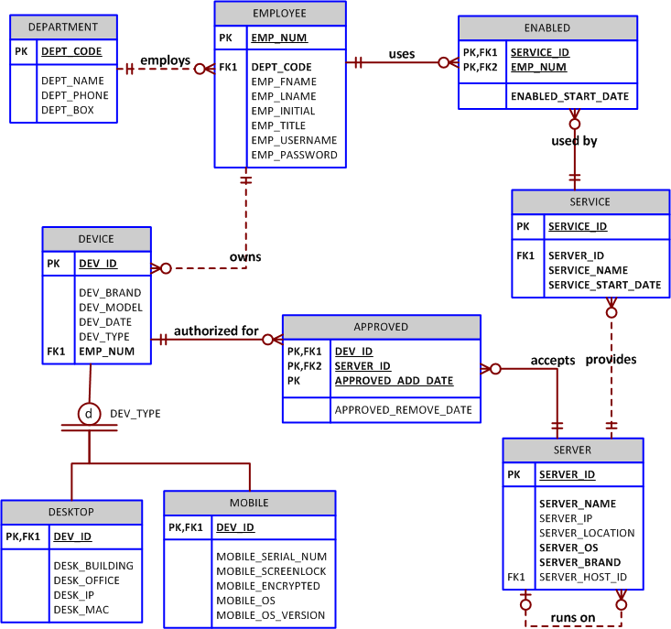

11. Global Computer Solutions (GCS) is an information technology consulting company with many offices located throughout the United States. The company’s success is based on its ability to maximize its resources—that is, its ability to match highly skilled employees with projects according to region. To better manage its projects, GCS has contacted you to design a database so that GCS managers can keep track of their customers, employees, projects, project schedules, assignments, and invoices.

The GCS database must support all of GCS’s operations and information requirements. A basic description of the main entities follows:

- The employees working for GCS have an employee ID, an employee last name, a middle initial, a first name, a region, and a date of hire recorded in the system.
- Valid regions are as follows: Northwest (NW), Southwest (SW), Midwest North (MN), Midwest South (MS), Northeast (NE), and Southeast (SE).
- Each employee has many skills, and many employees have the same skill.
- Each skill has a skill ID, description, and rate of pay. Valid skills are as follows: Data Entry I, Data Entry II, Systems Analyst I, Systems Analyst II, Database Designer I, Database Designer II, Java I, Java II, C++ I, C++ II, Phyton I, Phyton II, ColdFusion I, ColdFusion II, ASP I, ASP II, Oracle DBA, MS SQL Server DBA, Network Engineer I, Network Engineer II, Web Administrator, Technical Writer, and Project Manager. Table P5.11a shows an example of the Skills Inventory.

Skill | Employee
Data Entry I | Seaton Amy; Williams Josh; Underwood Trish
Data Entry II | Williams Josh; Seaton Amy
Systems Analyst I | Craig Brett; Sewell Beth; Robbins Erin; Bush Emily; Zebras Steve
Systems Analyst II | Chandler Joseph; Burklow Shane; Robbins Erin
DB Designer I | Yarbrough Peter; Smith Mary
DB Designer II | Yarbrough Peter; Pascoe Jonathan
Cobol I | Kattan Chris; Epahnor Victor; Summers Anna; Ellis Maria
Cobol II | Kattan Chris; Epahnor Victor, Batts Melissa
C++ I | Smith Jose; Rogers Adam; Cope Leslie
C++ II | Rogers Adam; Bible Hanah
VB I | Zebras Steve; Ellis Maria
VB II | Zebras Steve; Newton Christopher
ColdFusion I | Duarte Miriam; Bush Emily
ColdFusion II | Bush Emily; Newton Christopher
ASP I | Duarte Miriam; Bush Emily
ASP II | Duarte Miriam; Newton Christopher
Oracle DBA | Smith Jose; Pascoe Jonathan
SQL Server DBA | Yarbrough Peter; Smith Jose
Network Engineer I | Bush Emily; Smith Mary
Network Engineer II | Bush Emily; Smith Mary
Web Administrator | Bush Emily; Smith Mary; Newton Christopher
Technical Writer | Kilby Surgena; Bender Larry
Project Manager | Paine Brad; Mudd Roger; Kenyon Tiffany; Connor Sean

Table P5.11a Skills Inventory

- GCS has many customers. Each customer has a customer ID, customer name, phone number, and region.
- GCS works by projects. A project is based on a contract between the customer and GCS to design, develop, and implement a computerized solution. Each project has specific characteristics such as the project ID, the customer to which the project belongs, a brief description, a project date (the date the contract was signed), an estimated project start date and end date, an estimated project budget, an actual start date, an actual end date, an actual cost, and one employee assigned as manager of the project.
- The actual cost of the project is updated each Friday by adding that week’s cost to the actual cost. The weeks cost is computed by multiplying the hours each employee worked by the rate of pay of the project.
- The employee who is the manager of the project must complete a project schedule, which effectively is a design and development plan. In the project schedule (or plan), the manager must determine the tasks that will be performed to take the project from beginning to end. Each task has a task ID, a brief task description, starting and ending dates, the type of skills needed, and the number of employees (with the required skills) needed to complete the task. General tasks are the initial interview, database and system design, implementation, coding, testing, and final evaluation and sign-off. For example, GCS might have the project schedule shown in Table P5.11b.

Project ID: 1 Description: Sales Management System
Company : See Rocks Contract Date: 2/12/2018 Region: NW
Start Date: 3/1/2018 End Date: 7/1/2018 Budget: $15,500
Start Date | End Date | Task  Description | Skill(s)  Required | Quantity Required
3/1/18 | 3/6/18 | Initial Interview | Project Manager  Systems Analyst II  DB Designer I | 1  1  1
3/11/18 | 3/15/18 | Database Design | DB Designer I | 1
3/11/18 | 4/12/18 | System Design | Systems Analyst II  Systems Analyst I | 1  2
3/18/18 | 3/22/18 | Database Implementation | Oracle DBA | 1
3/25/18 | 5/20/18 | System Coding & Testing | Java I  Java II  Oracle DBA | 2  1  1
3/25/18 | 6/7/18 | System Documentation | Technical Writer | 1
6/10/18 | 6/14/18 | Final Evaluation | Project Manager  Systems Analyst II  DB Designer I  Java II | 1  1  1  1
6/17/18 | 6/21/18 | On-Site System Online and Data Loading | Project Manager  Systems Analyst II  DB Designer I  Java II | 1  1  1  1
7/1/18 | 7/1/18 | Sign-Off | Project Manager | 1

Table P5.11b Project Schedule Form

- Assignments: GCS pools all of its employees by region, and from this pool, employees are assigned to a specific task scheduled by the project manager. For example, in the first project’s schedule, you know that a Systems Analyst II, Database Designer I, and Project Manager are needed for the period from 3/1/18 to 3/6/18. The project manager is assigned when the project is created and remains for the duration of the project. Using that information, GCS searches the employees who are located in the same region as the customer, matching the skills required and assigns the employees to the project task.
- Each project schedule task can have many employees assigned to it, and a given employee can work on multiple project tasks. However, an employee can work on only one project task at a time. For example, if an employee is already assigned to work on a project task from 2/20/18 to 3/3/18, the employee cannot work on another task until the current assignment is closed (ends). The date on which an assignment is closed does not necessarily match the ending date of the project schedule task, because a task can be completed ahead of or behind schedule. The date on which an assignment is closed does not necessarily match the ending date of the project schedule task because a task can be completed ahead of or behind schedule.
- Given all of the preceding information, you can see that the assignment associates an employee with a project task, using the project schedule. Therefore, to keep track of the assignment, you require at least the following information: assignment ID, employee, project schedule task, assignment start date, and assignment end date. Th end date could be any date, as some projects run ahead of or behind schedule. Table P5.11c shows a sample assignment form.

Project ID: 1 Description: Sales Management System
Company: See Rocks Contract Date: 2/12/2018 As of: 03/29/18
SCHEDULED |  |  |  | ACTUAL ASSIGNMENTS
Project  Task | Start  Date | End Date | Skill | Employee | Start Date | End Date
Initial Interview | 3/1/18 | 3/6/18 | Project Mgr.  Sys. Analyst II  DB Designer I | 101—Connor S.  102—Burklow S.  103—Smith M. | 3/1/18  3/1/18  3/1/18 | 3/6/18  3/6/18  3/6/18
Database Design | 3/11/18 | 3/15/18 | DB Designer I | 104—Smith M. | 3/11/18 | 3/14/18
System Design | 3/11/18 | 4/12/18 | Sys. Analyst II  Sys. Analyst I  Sys. Analyst I | 105—Burklow S.  106—Bush E.  107—Zebras S. | 3/11/18  3/11/18  3/11/18
Database Implementation | 3/18/18 | 3/22/18 | Oracle DBA | 108—Smith J. | 3/15/18 | 3/19/18
System Coding & Testing | 3/25/18 | 5/20/18 | Java I  Java I  Java II  Oracle DBA | 109—Summers A.  110—Ellis M.  111—Ephanor V.  112—Smith J. | 3/21/18  3/21/18  3/21/18  3/21/18
System Documentation | 3/25/18 | 6/7/18 | Tech. Writer | 113—Kilby S. | 3/25/18
Final Evaluation | 6/10/18 | 6/14/18 | Project Mgr.  Sys. Analyst II  DB Designer I  Java II
On-Site System Online and Data Loading | 6/17/18 | 6/21/18 | Project Mgr.  Sys. Analyst II  DB Designer I  Java II
Sign-Off | 7/1/18 | 7/1/18 | Project Mgr.

Table P5.11c Project Assignment Form
(Note: The assignment number is shown as a prefix of the employee name; for example, 101, 102.) Assume that the assignments shown previously are the only ones existing as of the date of this design. The assignment number can be whatever number matches your database design.
- The hours an employee works are kept in a work log containing a record of the actual hours worked by an employee on a given assignment. The work log is a weekly form that the employee fills out at the end of each week (Friday) or at the end of each month. The form contains the date, which is the current Friday of the month or the last workday of the month if it doesn’t falls on a Friday. The form also contains the assignment ID, the total hours worked either that week or up to the end of the month, and the bill number to which the work log entry is charged. Obviously, each work log entry can be related to only one bill. A sample list of the current work log entries for the first sample project is shown in Figure P5.11d.

Employee  Name | Week  Ending | Assignment  Number | Hours  Worked | Bill  Number
Burklow S. | 3/1/18 | 1-102 | 4 | xxx
Connor S. | 3/1/18 | 1-101 | 4 | xxx
Smith M. | 3/1/18 | 1-103 | 4 | xxx
Burklow S. | 3/8/18 | 1-102 | 24 | xxx
Connor S. | 3/8/18 | 1-101 | 24 | xxx
Smith M. | 3/8/18 | 1-103 | 24 | xxx
Burklow S. | 3/15/18 | 1-105 | 40 | xxx
Bush E. | 3/15/18 | 1-106 | 40 | xxx
Smith J. | 3/15/18 | 1-108 | 6 | xxx
Smith M. | 3/15/18 | 1-104 | 32 | xxx
Zebras S. | 3/15/18 | 1-107 | 35 | xxx
Burklow S. | 3/22/18 | 1-105 | 40
Bush E. | 3/22/18 | 1-106 | 40
Ellis M. | 3/22/18 | 1-110 | 12
Ephanor V. | 3/22/18 | 1-111 | 12
Smith J. | 3/22/18 | 1-108 | 12
Smith J. | 3/22/18 | 1-112 | 12
Summers A. | 3/22/18 | 1-109 | 12
Zebras S. | 3/22/18 | 1-107 | 35
Burklow S. | 3/29/18 | 1-105 | 40
Bush E. | 3/29/18 | 1-106 | 40
Ellis M. | 3/29/18 | 1-110 | 35
Ephanor V. | 3/29/18 | 1-111 | 35
Kilby S. | 3/29/18 | 1-113 | 40
Smith J. | 3/29/18 | 1-112 | 35
Summers A. | 3/29/18 | 1-109 | 35
Zebras S. | 3/29/18 | 1-107 | 35
Note: xxx represents the bill ID. Use the one that matches the bill number in your database.

Table P5.11d Project Work-Log Form as of 3/29/18

(Note: xxx represents the bill ID. Use the one that matches the bill number in your database.)
- Finally, every 15 days, a bill is written and sent to the customer for the total hours worked on the project during that period. When GCS generates a bill, it uses the bill number to update the work-log entries that are part of that bill. In summary, a bill can refer to many work log entries, and each work log entry can be related to only one bill. GCS sent one bill on 3/15/18 for the first project (SEE ROCKS), totaling the hours worked between 3/1/18 and 3/15/18. Therefore, you can safely assume that there is only one bill in this table and that the bill covers the work-log entries shown in the preceding form.

Your assignment is to create a database that will fulfill the operations described in this problem. The minimum required entities are employee, skill, customer, region, project, project schedule, assignment, work log, and bill. (There are additional required entities that are not listed.)
- Create all of the required tables and all of the required relationships.
- Create the required indexes to maintain entity integrity when using surrogate primary keys.
- Populate the tables as needed, as indicated in the sample data and forms.

This is a complex database design case that requires the identification of many business rules, the organization of those business rules, and the development of a complete database model. Note that this database design case has three primary objectives:
- Evaluation of primary keys and surrogate keys. (When should each one be used?)
- Evaluation of the use of indexes on candidate keys to avoid duplicate entries when using surrogate keys.
- Evaluation of the use of redundant relationships. In some cases, it is better to have the foreign key attribute added to an entity, instead of using multiple join operations.

We recommend that you use this problem as the basis for a two part case project. One way to work with this database case is to form small groups of two or three students and then let each group work the problem independently. The following bullet list provides a sample scenario:
- Divide the class in groups of three students per group.
- Distribute the GCS database case to all students.
- Assign a deadline for the groups to submit an initial design ERD with written explanations of the ERD components and features. This deadline should be two weeks from the assignment date. (While the groups are working on the design phase, students will be learning to use SQL to generate information.)
- The initial ERD must include:
- All the main entities with all primary/foreign keys clearly labeled.
- The identification of all relevant dependent attributes.
- For each table, the identification of all possible required indexes.
- Meet with each group and evaluate each design, paying close attention to:
- The propagation of primary/foreign keys and how surrogate keys would be useful to simplify the design.
- The use of indexes to minimize the occurrence of duplicate entries.
- By this time, students should be familiar with SQL. Ask questions about how a query would be written to generate information. You can use the sample queries provided in the GCSdata-sol.mdb teacher solution file. This database is located on your Instructor’s CD.)

Please note that there are two database files available:

- The GCSdata.mdb database is located in the Student subfolder on the Instructor’s CD. This MS Access database contains the sample CUSTOMER, EMPLOYEE, REGION, and SKILL tables. You can either distribute this file to your students by copying it to a common drive in your lab or you can ask your students to download this file from the Course Technology website for this book.
- The GCSdata-sol.mdb database is located in the Teacher subfolder on the Instructor’s CD. This MS Access database contains the complete set of populated tables. In addition, the solution database contains some sample queries. You can use the sample queries as the basis for second part of this case, which may be used to complement the SQL coverage in chapters 7 and 8.

Figure P5-11a shows the sample tables in the GCSdata.mdb student database.

Figure P5-11a GCS Student Sample Database Tables
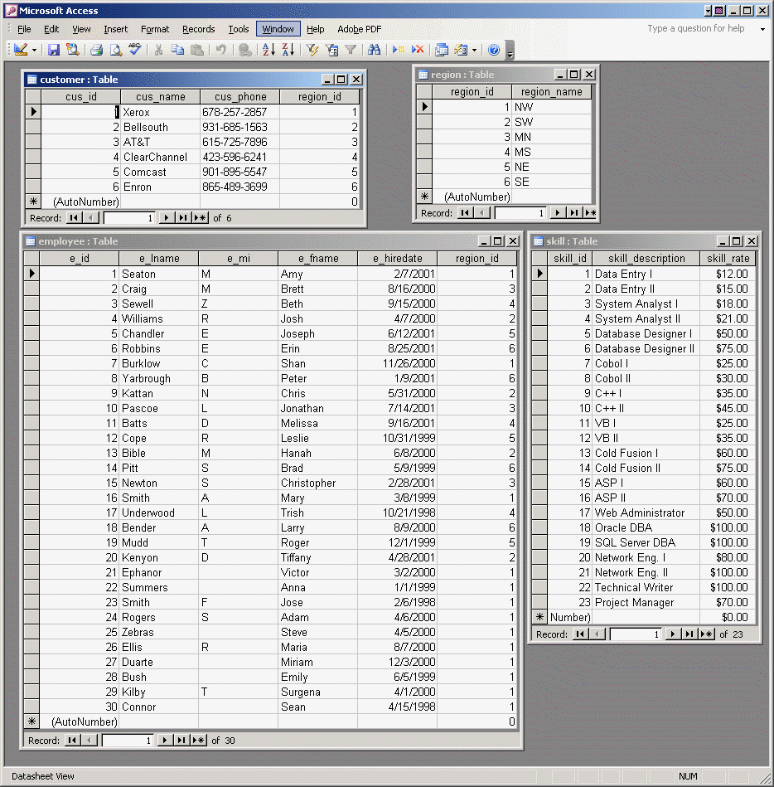

The GCSdata-sol.mdb file contains the solution for this design case. Figure P5-11b shows the relational diagram for the solution.

Figure P5.11b – Relational Diagram for the GCS Database
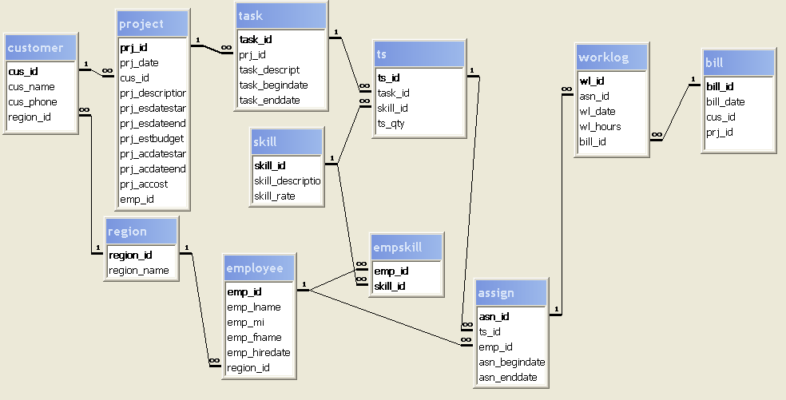

To help your students understand the ERD, use Table P5.11 to describe the main tables and the main indexes that are appropriate for this design implementation.

TABLE P5.11 ERD Documentation
Table  Name | Primary key | Unique, Not Null Index  (on candidate key) | Explanation
Customer | cus_id (surrogate) | unique(cus_name) | The unique index on cus_name is used to ensure no duplicate customers exist.
Region | region_id (surrogate) | unique(region_name) | The unique index on region_name is used to ensure that no duplicate regions are entered.
Employee | emp_id (surrogate) | unique(emp_lname, emp_fname, emp_mi) | The unique index on emp_lname, emp_fname and emp_mi is used to ensure that no duplicate employees are entered.
Skill | skill_id (surrogate) | unique(skill_description) | The unique index on skill_description is used to ensure that no duplicate skills are entered.
EmpSkill | emp_id, skill_id  (composite) |  | The composite primary key ensures that no duplicate skills are entered for each employee.
Project | prj_id (surrogate) | unique(cus_id, prj_description) | The unique index on cus_id and prj_description is used to ensure that no duplicate project entries exist for a given customer.
Task (project schedule) | task_id (surrogate) | unique(prj_id, task_descript) | The unique index on prj_id and task_descript is used to ensure that no duplicate task is given for the same project.
TS  (task schedule) | ts_id(surrogate) | unique(task_id, skill_id) | The unique index on task_id and skill_id is to prevent duplicate listings for a single skill within a single task for a single project.
Assign | asn_id (surrogate) | unique (ps_id, emp_id, ts_id) | The unique index on ps_id, emp_id, and ts_id is used to ensure that an employee cannot be assigned twice to perform the same skill on the same task for a given project.
Worklog | wl_id (surrogate) | unique(asn_id, wl_date) | The unique indexes on asn_id and wl_date are used to ensure that no duplicate work log entries exist (for an employee) on a given date.
Bill | bill_id (surrogate)

It is important to point out to your students that the surrogate primary keys are usually not shown in the graphical user interfaces that are available to the end users. The only function of the surrogate primary key is to provide a single-attribute identifier for each row in the table.
The completed ERD for the GCS database is shown in Figure P5-11C.
Figure P5.11c – ERD for the GCS Database
